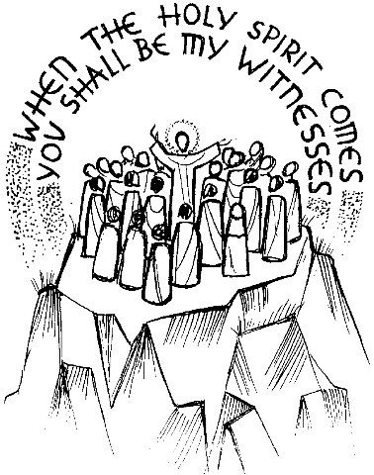
Sunday 17 May 2026
Welcome

www.st-matthias-church.org
The 11am on Sunday is live-streamed so you can join us
in Church or online (or even worship later in the day or week!)
www.youtube.com/@stmatthiaschurchtorquay6827/streams

Sun 17 May | 8am | Holy Communion (Book of Common Prayer)
 | 9:30am | Explore Together
 | 10:30am | Gather to Pray
 | 11am |   Holy Communion followed by tea/coffee  tinyurl.com/bw2c4966
 | 4pm | APCM
 | 6pm | ‘Thy Kingdom Come’ at Exeter Cathedral
Mon 18 May | 9am | Morning Prayer – on zoom – details below
Tue 19 May | 9am | Morning Prayer – on zoom – details below
 | 9-11:30am | Toddlers
 | 12-1:30pm | St Matt’s Knits
 | 3.15-5.30 | Messy Church
Wed 20 May | 9 – 12.00 | Holy Communion followed by time of prayer
 | 12-2pm | Welcome Space – coffee, soup and chat!
Fri 22 May | 9-11:30am | Mummy & Me
 | 6:30-8pm | Youth Club
Sun 24 May | 8am | Holy Communion (Book of Common Prayer)
Pentecost | 9:30am | Explore Together
 | 10:30am | Gather to Pray
 | 11am | Morning Worship followed by tea/coffee
 |  | There is no Praise@5.30 this month
For Morning Prayer online, we use the Church of England ‘Daily Prayer’ app
and this zoom link: tinyurl.com/2t56wex5 You are welcome to join us!
The words we use can be found here, with an audio version: tinyurl.com/2djd3t7f

Church Office: Susie Williams 01803 214175 admin@st-matthias-church.org
Rector: From August – Rev’d Stephen Yates
Associate Minister: Rev’d Paul Barton 07807 636470 revpaulbarton@gmail.com
Assistant Clergy: Rev’d Dallas Ayling 07806 608220 revddallasayling@yahoo.co.uk
Youth & Children: Helen Baker 07832 738998 helen.baker@st-matthias-church.org

Our thanks go to: All who work with our children and young people.
Collect: Risen, ascended Lord, as we rejoice at
your triumph, fill your Church on earth with
power and compassion, that all who are
ensnared by sin may find forgiveness and
know your peace, to the glory of God the
Father. Amen

Readings for this Sunday

Acts 1:1-11 (NIV UK)
1 In my former book, Theophilus, I wrote about all that Jesus began to do and to teach ² until the day he was taken up to heaven, after giving instructions through the Holy Spirit to the apostles he had chosen. ³ After his suffering, he presented himself to them and gave many convincing proofs that he was alive. He appeared to them over a period of forty days and spoke about the kingdom of God. ⁴ On one occasion, while he was eating with them, he gave them this command: “Do not leave Jerusalem, but wait for the gift my Father promised, which you have heard me speak about. ⁵ For John baptized with water, but in a few days you will be baptized with the Holy Spirit.”⁶ Then they gathered around him and asked him, “Lord, are you at this time going to restore the kingdom to Israel?”
⁷ He said to them: “It is not for you to know the times or dates the Father has set by his own authority. ⁸ But you will receive power when the Holy Spirit comes on you; and you will be my witnesses in Jerusalem, and in all Judea and Samaria, and to the ends of the earth.” ⁹ After he said this, he was taken up before their very eyes, and a cloud hid him from their sight.
¹⁰ They were looking intently up into the sky as he was going, when suddenly two men dressed in white stood beside them. ¹¹ “Men of Galilee,” they said, “why do you stand here looking into the sky? This same Jesus, who has been taken from you into heaven, will come back in the same way you have seen him go into heaven.”

John 14:1-14 (NIV UK)
17 After Jesus said this, he looked towards heaven and prayed: ‘Father, the hour has come. Glorify your Son, that your Son may glorify you. ² For you granted him authority over all people that he might give eternal life to all those you have given him. ³ Now this is eternal life: that they know you, the only true God, and Jesus Christ, whom you have sent. ⁴ I have brought you glory on earth by finishing the work you gave me to do. ⁵ And now, Father, glorify me in your presence with the glory I had with you before the world began. ⁶ ‘I have revealed you to those whom you gave me out of the world. They were yours; you gave them to me and they have obeyed your word. ⁷ Now they know that everything you have given me comes from you. ⁸ For I gave them the words you gave me and they accepted them. They knew with certainty that I came from you, and they believed that you sent me. ⁹ I pray for them. I am not praying for the world, but for those you have given me, for they are yours. ¹⁰ All I have is yours, and all you have is mine. And glory has come to me through them. ¹¹ I will remain in the world no longer, but they are still in the world, and I am coming to you. Holy Father, protect them by the power of your name, the name you gave me, so that they may be one as we are one.
News
School News

Ecoaction for May - find out more about our local marine environment, for example the seagrass beds, the Torbay and Lyme Bay marine conservation area - and put Marine Ecofest (organised and hosted by St Matt's) on 18th July in your diary!

Christian Aid Week
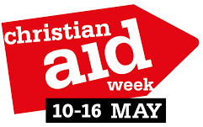
This Sunday marks the end of Christian Aid Week, but it

is never too late to explore their ministry or donate to their work. tinyurl.com/489ydf4v takes you to a donation page or use the QR code.

Dates for your diary
Marine EcoFest. This day event organised by the St Matthias EcoAction Group will be held on 18th July at the church. Please put in your diaries. It will be a major event for Torbay, looking at so many aspects of the marine environment around us; sustainability, clean waters, sea life, safety, beaches and enjoying the bay. Many activities for families in the morning and a series of excellent talks in the afternoon. More follows


Thy Kingdom Come is a global ecumenical prayer movement that invites Christians around the world to pray from Ascension to Pentecost 14-24 May 2026 to pray for more people to come to know Jesus, and specifically for the 5 people God prompts us about.
Join us on Wednesday morning in the Chapel where we will begin with communion – feel free to drop in for any part of the morning! Download the App -for daily prayers, or find resources at www.thykingdomcome.global/

Messy Church from 3.15pm in the hall on Tuesday 19th May.
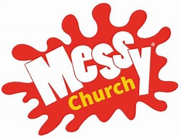
An engaging afternoon for primary school children and their families. Craft, Bible stories, Games and Food. If you would like to experience the joy of getting involved in making this even more special, please come and see Helen.

Dine-out Sundays Our next lunch is on 24th May at 1.15pm at The Central Conservative Club, Torquay. Please note the change of time, and contact Gill on 07709 727714, for further information or to book.


Christians Against Poverty have trained members at Upton Vale Baptist Church to offer free help to people to better manage their money. You need to sign up for the 3 sessions on 4, 11 and 18 June from 7-9pm by phoning 01803 400403

Crosslight – Paul Burbridge and Les Ellison’s One-Act Passion Play at the Royal Lyceum 18-20 June @ 7.30pm, Saturday Matinee at 2.30pm.
Book online at www.unleashedtheatrecompany.com/
'The disciple chosen to lead is in pieces. Caught in the crosslight of the flickering candles at the Last Supper, the torches of Gethsemane, the firelight in the courtyard, by the searching gaze of Jesus, Simon ‘the Rock’ is shattered. A small group of family and friends stands by until the agony ends. But the great friend who, more than any other, has stood by Jesus throughout the story is conspicuous by his absence.
Crosslight draws us into the room with Mary, John and Peter hours after the crucifixion and into the experience of one disciple who failed, despite everything he believed so passionately…’

Prayers for the week
Mon | Pray for leaders in St Matthias - particularly the church wardens and clergy as we await our new Rector.
Tue | Syria has 300,00 Christians - a persecuted minority - but a church with an ancient history. They are now caught in the crossfire of other political and religious factions. Please pray for them.
Wed | We are spending the morning praying in the Francis Chapel that God’s “kingdom will come”. Pray that God’s Spirit inspires our prayers and we will listen to God’s voice.
Thur | Two weeks ago, local elections (& national elections in Scotland & Wales) caused a political upheaval. Pray for politicians of all colours as they seek to work together for the common good. Pray for Hazel Foster as our new mayor in Torbay.
Fri | We pray for peace with justice in conflict zones - particularly in Iran, Gaza, Lebanon and Ukraine.
Sat | This is normally a day for families to spend time together. Pray that the business of life does not squeeze out quality family time.
Sun | We pray for our three services this morning. Pray that God meets with us as we come to him.

